|  |  |
| --- | --- |
| **NAME :** | P.SWETHA |
| **DEPARTMENT :** | INDUSTRIAL BIOTECHNOLOGY |
| **COLLEGE :** | GOVERNMENT COLLEGE OF TECHNOLOGY |
| **NAAN MUDHALVAN COURSE:** | DIGITAL MARKETING |
| **NAAN MUDHALVAN ID :** | A335D640DF1CCF2B86D4FA38F17A749B |

ASSIGNMENT ON DIGITAL MARKETING

1. Create a blog or website using blogspot and wordpress. Customize the theme design and post new article with 500 words

Blogspot:

<https://www.blogger.com/blog/posts/7524755109108294325>

1. Create a New Facebook Business Page and post one social media poster of your brand

<https://www.facebook.com/profile.php?id=61552161323101>

3.Create and design a social media advertisement poster using canva.

<https://swecoffee.blogspot.com/2023/10/infographic.html>

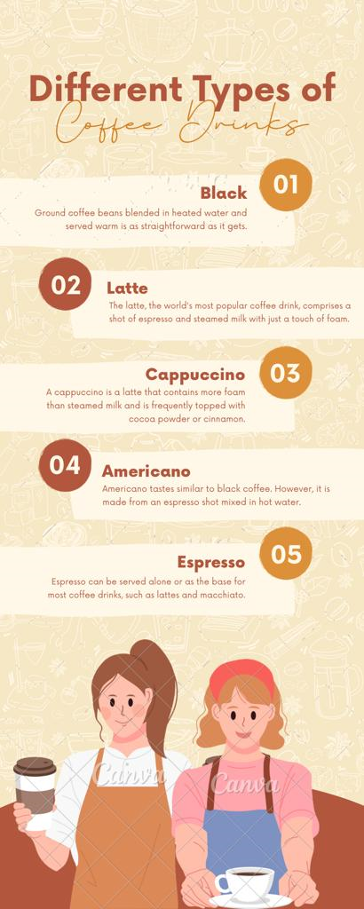

4.Create email newsletter design using MailChimp or canva tool.

<https://swecoffee.blogspot.com/2023/10/newspaper.html>

